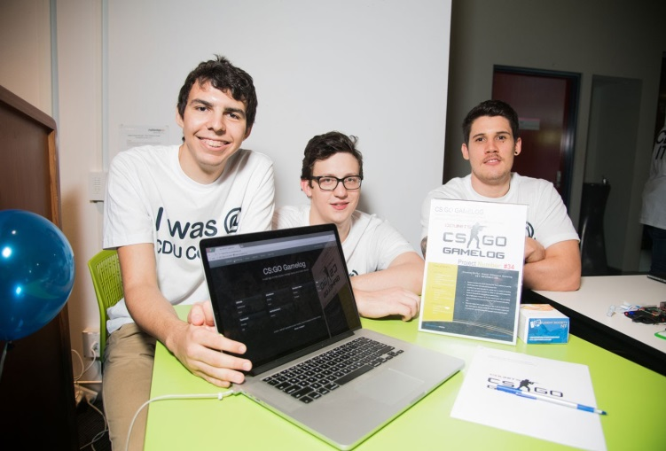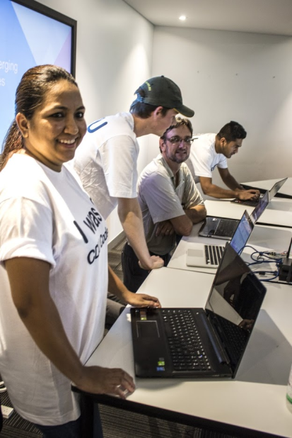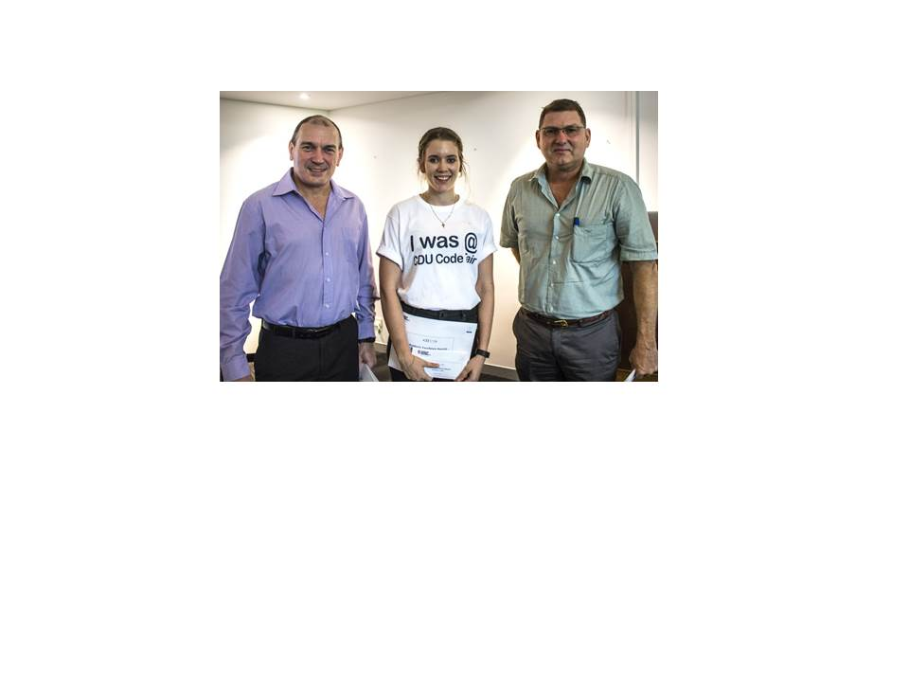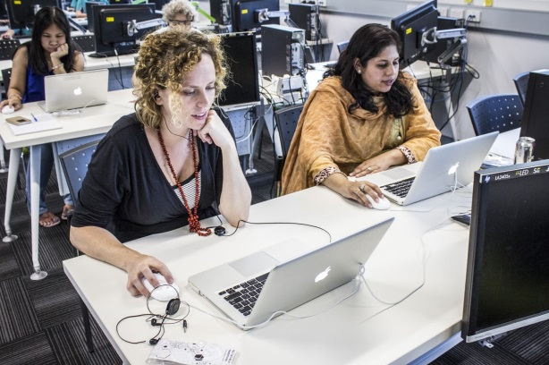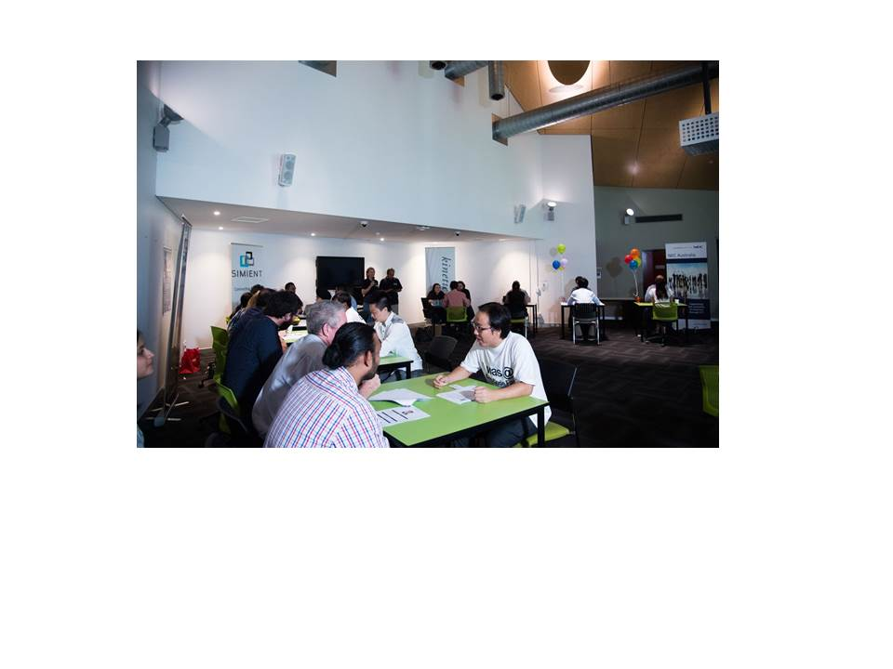

|  |
| --- |
| 2016 Business & IT Code Fair |
| The third Business & IT Code Fair was held on November 11, 2016.  This document provides an overview of the event and reports on feedback and updates to be implemented for 2017.  **CODE FAIR 2017 WILL BE HELD ON FRIDAY NOVEMBER 10, 2017.** |

2016 Business & IT Code Fair

## Introduction

# Industry Sponsors

• • •

School of Engineering & Information Technology would like to thank the following IT businesses for their sponsorship of the fair and the various competition prizes:

* NT Government Department of Corporate and Information Services
* Australian Computer Society
* Dialog
* Dolphin Software
* Kinetic IT
* Radical Systems
* Captovate
* Dash Media
* NEC
* JackAdder International

A huge thanks to industry members who participated in Speed Dating

* Captovate,
* CDU, ITMS & IMPS
* Dash Media
* Dialog
* Kinetic IT
* NEC
* Radical Systems
* Vertical Technology Group
* APSL
* Siement

Thank you to industry who provided judges:

* Dash Media
* Dialog
* Dolphin Software
* Kinetic IT
* MIP
* Radical Systems
* Relatonal Data Systems
* SRA

The third Business and IT Code Fair was held at Charles Darwin University’s North Australian Centre for Oil and Gas, November 11 from 9am – 3pm and was attended by a record number of students, industry partners and members of the IT and University communities.

NT Minister Lauren Moss (Minister for Corporate Information Services) opened the event and presented Academic Excellence awards to 12 students who had achieved the highest grades in individual IT units from first semester 2016. This included local and off campus students who were flown to Darwin to receive their awards and participate in the Code Fair. The sponsorship to make this new initiative possible, was provided by the NT Department of Corporate Information Services.

A second exciting addition to the Code Fair was a keynote presentation from Glenn Irvine (National Practice Manager Google Solutions for Dialog Information Technology) on Google’s Emerging Technologies where Glenn outlined some of the latest ongoing developments within Google regarding Google Cloud; Google Home, self-driving cars, robots and virtual reality. A Google Home device (a small speaker smart home system) was donated to the Code Fair as a prize for the People’s Choice awards voted by visitors to the Code Fair and presented by Minister Moss at the end of the day. The sponsorship from Dialog Information Technology to organize Glenn to present at the Code Fair and provide the Google Home was terrific.

## Code Fair Goals

Currently Charles Darwin University has five VET courses in IT; seven undergraduate courses and 2 post graduate IT courses. At least 60% of students who enroll in both undergraduate and postgraduate courses are International, with English as a second language, they are male and between the ages of 19 – 35. There are approximately 180 UG students in the program and 50 Masters students.

# Thank you Judges

• • •

A huge thank you to all the judges in the various competitions:

Jude Ellen (Dolphin)

Jason Carney (Dash Media)

Bronwyn Lo (DCIS)

Sam Hall (CDU ITMS)

Matt Elvey (CDU IMPS)

Aaron Hay (DCIS, Radical)

Nare Vella (Dialog)

Jordan Ware (Radical)

Kinetic IT (2 judges)

Amir Eshan (APSL)  
Pat Turner (APSL)

Ferdi Klesch (VET IT)

Rowan Hawthorne (CDU)

Robert Chergwin (ACS)

Richard Black (NEC)

Lisa Jeffery (CDU, Drafting & Construction)

Justin Schmidt

Lou Martini (JackAdder International)

Lien Bui (IT Alumni)

Coral Campbell (CDU Academic Languages)

The code fair provides a means to encourage and support students’ coding development showcasing their work more broadly to the University and industry communities. To celebrate the international hour of code is also part of the goals to promote coding throughout the educational community so the Code Fair reaches out to the secondary school community with code hour workshops. A final aspect of the code fair is to help all IT students meet local businesses with a view to facilitate future employment pathways.

## Code Fair Events

Code Fair 2016 included six major activities:

1. Business Innovation Challenge

A new initiative, a Business Innovation Challenge, was introduced as a lead up event to 2016 Code Fair. Launched 6 weeks out from the Code Fair (just before end of semester assessment period!) this challenge, provided by the NT government, presented a real-life problem to students regarding how to communicate NT Road conditions using 21st century technologies. 7 students (1 team and 3 individuals) participated in the competition and the industry judges and academic staffs were highly impressed with the level of innovation all students displayed. Students had to create a prototype and or concept for solving the problem and then communicate this through a 5 minute presentation. Beside a monetary prize, the NT government have employed 5 students during summer as part of a development think tank so that their ideas can be turned into reality.

2. Coding competitions

The competition was open to all IT students (VET, and Higher Education) who had created apps; programs; mobile prototypes, websites, games that demonstrate their developing knowledge, skills in building elegant, maintainable code that works. 9 students submitted 9 examples of their works as individuals and 18 students submitted 7 examples of their works as 7 groups. Students were judged by a panel of industry judges in various categories associated with their level of study: novice, intermediate and advanced as individuals or groups. There was also an overall innovation prize awarded. One judge who has been part of the Code Fair since its inception noted that *there was a much higher standard than last year. I think the projects were well presented and there was some very clever work in there*. Prize winners are listed opposite.

# Prize Winners

• • •

#### **Business Innovation Challenge**

#### Winner

Robert Jackson

(Sponsor: Dialog Information Technology)

#### Runners Up

1. Team Meeru Pdmanabhan; Isaac Tauleieli; Jarrod OCallaghan: Nathan Wilson

(Sponsor: Dash Media)

1. Ayush Ghai

(Sponsor: ACS)

1. Augustine Thorbjornsen

(Sponsor: ACS)

#### **Innovation Award**

#### Winner

Jack Hackshaw for *Crypt Crawlers*

(Sponsor: ACS)

#### Runner Up

Jarrod O'Callaghan

Nathan Wilson,

Isaac Taulelei for *CS:GO GAMELOG*

(Sponsor: ACS)

#### **Poster Competition**

#### Winner

Ayush Ghai

(Sponsor: JackAdder International)

3. Poster competition

The poster competition was introduced in 2015 to encourage students whose IT pathways to a future career was in the more analytical aspects of the profession. The poster competition aims to encourage students to communicate their IT work and develop and expand their visual communication skills. In 2016, 12 students submitted 14 examples of their work.

4. Code Hour Workshops

Supporting the global ‘Hour of Code’ initiative to develop coding literacies, four x one hour (4 x 1 hour) workshops were run for 45 students from 3 local high schools (Casuarina Senior College, Darwin High School and Essington) and university staff. Students from Casuarina Secondary School spent the day at the code fair participating in many of the events on the day while 20 university staff attended the Coding workshop which was very popular.

A big thank you to our Code Workshop facilitators: Rebecca England; Bidhan Neupane and Ali Farzand. Bidhan and Ali this year are newly graduated CDU alumni who enjoyed the code fair so much they volunteered to come back and work with students to share their love of IT.

5. *Industry Employer Speed Dating*

Employer Speed provides graduating students an opportunity to meet local employers. This year there were two speed dating categories for students to enter: developer; and IT support and networking. 18 students took up the opportunity (13 Masters students & 5 UG students). Four new employers joined the 2016 Speed Dating and the timing for the ‘speed dating’ includes 1 minute for the student to make a pitch to a prospective employer and 2 minutes for the employer to ‘interview’ the students. Students are only allowed to participate in the speed dating if they have attended a preparation session which looks at aspects of: appropriate dress; body language; oral presentation skills and CV preparations. Students are giving an opportunity to trial their 1 minute pitch with all students asked to give feedback on how to make it better.

6. *Academic Excellence awards*

To encourage a greater emphasis on academic endeavours, this year a new category was introduced to recognise students who achieve highly in each subject taught in IT. Students who receive this award earn the highest scores in each unit. This initiative enabled the university to also reach out to our off campus students and two students were flown to Darwin courtesy of sponsorship from DCIS. 9 students were recognise for their academic endeavours and they are listed above.

# Prize Winners

• • •

#### **Best Novice Coder**

#### Winner

Joel Benesha

(Sponsor: ACS)

#### Runners Up

Jack Jackshaw

(Sponsor: ACS)

Alfonse Mugisho

(Sponsor: ACS)

#### **Best Intermediate Coder**

**Individual:** Aayush Sapkota

(Sponsor: Radical Systems)

**Team:**  Poonam Patel

1. Muhammad Shahab Iftikhar

(Sponsor: Radical Systems)

#### **Best Advanced Coder**

**Individual:** Robert Jackson

(Sponsor: Dialog)

**Team:**  Samuel Walledge, Phillip Davis

(Sponsor: Dialog)

# Code Fair 2017

To ensure that the Code Fair is meeting the needs of the various organizations who participate, consultations were held with staff, students, and industry to evaluate the event, and consider what worked and what could be improved, changed, adapted? The following discussion outlines the key themes arising from these discussions.

## What worked and should be continued

The following aspects of the 2016 code fair were commended:

* The ceremonies surrounding the opening by Minister Moss, the keynote speaker and the academic excellence awards provided a positive start to the fair.
* Overall the event ran well and built on previous years.
* The software projects were of a higher standard than previous years with some very clever work presented by some students with more involvement by VET, first year and remote students.
* The judging processes ran very smoothly
* The Business innovation challenge was welcomed as an important inclusion
* The online solutions and digital record keeping instituted by the project officer helped the event run more efficiently
* People’s Choice awards was effective in attracting more people to attend the event

## Changes to be considered into the future

## Venue & event management

All stakeholders agreed that the event has outgrown the current venue and a larger more suitable venue needs to be found that has a better AV and sound system and preferably a stage of some sort. Ideas for a range of different venues were canvassed including:

* CDU Waterfront

# Prize Winners

• • •

#### **People’s Choice Awards**

#### **Coding**

#### Winner VET

Jack Jackshaw

(Sponsor: NEC)

Winner Undergraduate (1st, 2nd year)

Joel Benesha

(Sponsor: Kinetic IT)

Winner Undergraduate

(3rd, 4th year)

Robert Jackson

(Sponsor: Kinetic IT)

Winner Postgraduate

Poonam Patel +

Muhammad Shahab Iftikhar

(Sponsor: Captovate)

#### **Posters**

Winner Undergraduate Augustine Thorbjornsen (Sponsor: Captovate)

Winner Postgraduate, Chaoketu Saiyin

(Sponsor: Captovate)

* Parliament House
* Convention Centre
* CDU Library
* CDU Music theatre
* CDU Central teaching building.

While some outdoor venues were discussed, it was noted that in November in Darwin, these were likely to become quite uncomfortable and that air conditioning was a necessity. IT staff noted that venue change would need to occur in a staged manner as the logistics of taking students to the city area was somewhat problematic for 2017. However they committed to canvas a variety of spaces at CDU Casuarina to initially improve the situation for 2017.

To professionalise the event further, it was also suggested to consider a professional MC perhaps in collaboration with Territory FM the radio station based at CDU to enable IT staff to focus on the event. Other suggestions regarding future Code Fair’s include:

* exploring the possibility of partnerships with other NT government departments who are also interested in promoting IT capacity and capabilities (e.g. Education Department)
* inviting more government departments – this is more likely if the event moves to the city
* refocus the event as *pathways to the profession* to ensure students understand what a ‘professional’ IT career involves: while working with code is important, there are many other aspects of the IT industry.
* consider online streaming of the event and increasing the media profile of the event
* develop pre-recorded interviews around the student entries which can be disseminated before the event as part of the profile raising
* profile sponsors better in any advertising through video or social media.
* think about the atmosphere that is being created by the Code Fair: while the current events have had lots of energy, consider how this could be emphasized more
* perhaps consider more than one keynote speaker
* capture student video testimonials regarding the code fair 2016 to run for 2017

All of these suggestions will be considered when 2017 planning begins. A first meeting of the industry stakeholder group is tentatively scheduled for early March, 2017 to further discuss some of the issues outlined above.

# Academic Awards

• • •

Congratulations to the following students who were the top performers academically in 2016 IT curriculum.

Sam Hood

Jason Mu (x2)

Samuel Walledge (x 2)

William Page

Breanna Kerle (x 2)

Ayush Ghai

Roy Galet

Phillip Davis

Pratap Adhikari

## Student participation & recruitment

Student participation has grown as the event develops further categories and means for students to become involved. However the numbers of students in the early years of study continue to be small and recruiting students is an ongoing challenge.

Two major successes in the 2016 was the inclusion of the first VET student Jack Hackshaw who took out the overall *Innovation award*  and a tidy prize sum of $600 which he plans to spend on a record player! Secondly a pre Code Fair lunch time session (*How to get a job in IT)* to launch the Business Innovation Challenge was presented by Michael Hawkes from Captovate representing the NT ICT industry association. Approximately 70 students attended this event.

Some general suggestions and observations were made to increase student participation. These include

* Creating more of a focus on the Code Fair competition through the assessment tasks in all IT units: Staff have already nominated a range of units where the assessments can be tweaked to promote the Code Fair for 2017.
* Include a Code Fair task as part of the VET industry training requirements so that more students from the VET sector are encouraged to participate
* Consider several lead up events through the year: hackathons (for individuals and teams) that focus on different aspects of IT. Suggestions include competitions to build a computer; cyber security challenges, a datathon; Business Innovation Challenge; geospatial challenges. Potential dates for these could be the mid semester breaks; the semester university holidays; and or the Race Day long weekend in August. To engage more students these competitions, events could be extended to secondary school students.
* Begin advertising the Code Fair from early in 2017 through digital and paper flyers that are posted in classrooms and through social media. In particular work with the fledgling IT students association to help promote the event to students.
* Use Google Docs to survey students regarding Code Fair interest early in 2017.

## Coding competition: display and judging.

### Student display of software

In 2016, the entries in the competition were more diverse and students shared their work with great enthusiasm. However, it was noted that students required more preparation in how to ‘pitch’ their products. Many students while being judged did not know what to present – and some found it difficult to discuss aspects of their code – i.e. the structure.

IT Staff resolved to provide more training around this aspect of the Coding competition for students:

All students would be required to make a 1 minute video ‘pitch’ of their project which would be loaded into a YouTube channel. This information along with a better overview of the software product (i.e. especially the context of use) would be provided to judges prior to the competition judging.

#### Judging the software

Judging the software in this event was very efficient: many judges had been involved for three years. This experience has now led to some more fine tuning of the process. there were a number recommendations made to refine the judging processes. These include:

* The judging matrix and criteria work well but there is no need for the numeric values
* Consider different criteria for the innovation award
* Clarify what is being judged: the code or the product
* Judging code on small laptop screens can be difficult
* Provide opportunities for judges to provide feedback to students when the prizes are being announced so that all students benefit more from this feedback.
* As well as the sponsors presenting the prizes, build in time for the judges of each category to provide some general information to students
* Consider giving certificates of participation to all students as well as the students who have received prizes
* Ensure that there is space to hear what the students are pitching
* Make sure all students know how to ‘pitch’ their software.
* Only give prizes where the standard is high enough
* Video the conversations around judging to show students

## 4: Employer Speed Dating

Once again, as this was the third year of employer speed dating, the process and concept had matured and the event flowed smoothly with the timing working well. All students who were part of the speed dating had attended a preparation event and this was evident. The two categories were also useful and saw a number of new industry involvement as a result.

Ideas for further refinement of this process include:

* Encourage students to do more preparation for this event by looking up the businesses involved and finding out what they do
* Based on this information then tailor their message to that specific business.
* Students need to ‘sell themselves’: how can they help the particular business they are meeting.
* Students need to be able to communicate what ‘value’ they bring to the business.
* Employers are looking for digital evidence: URL to a portfolio or GitHub site.
* The time of the speed dating is short: consider leaving people with customized digital resumes.

## 5: Hour of Code

The Hour of Code had an initial good response from schools, however the participation on the day was decreased due to the requirements associated with high school students coming on campus: this includes the permissions to access the internet; bus travel. There was also an increasing interest from University staff regarding the coding workshops and high numbers registered for the event.

Some suggestions for further consideration for this aspect of the code fair included:

* Think about timing – does the student hour of code sessions need to be held on the day? Would it be better to hold regular sessions throughout the year/semester?
* Think about how high schools students could be more involved with the fair itself?
* What partnerships are possible with schools and the Education Department?
* What level of schooling should be targeted – is this the most appropriate currently
* It was noted that schools that were highly engaged with the School Business Innovation challenge were Casuarina Secondary and Good Shepherd in Darwin and Alice Springs. Perhaps this provided further opportunities.
* Perhaps invite some high school representatives to the March meetings.